Substitute Teacher/TA Handbook & Guide
MISSION STATEMENT: The Ichabod Crane Central School District is dedicated to preparing students to become contributing members of society in an ever-changing world by valuing diversity; providing a safe environment; and promoting unique talents, a desire for life-long learning, a strong spirit of community, and Rider pride.

TABLE OF CONTENTS

Getting Started | Page
How do I become a sub at IC……..………………………………………………………………………………….. | 2
Accepting a sub position at IC……………………………………………………………………………………….. | 2
Job Expectations……………………………………………………………………………………………………………. | 3
Starting/Ending The Day
Primary School……………………………………………………………………………………………………………… | 4-5
Middle School……………………………………………………………………………………………………………….. | 6-7
High School ………………………………………………………………………………………………………………….. | 8-9
Important Information
Emergency Procedures………………………………………………………………………………………………….. | 10
Pay………………………………………………………………………………………………………………………………... | 10
Helpful Hints
Technology in the Classroom…………………………………………………………………………………………  Technology Troubleshooting………………………………………………………………………………………….  Tips, Tricks and Ideas……………………………….……………………………………………………………………. | 11  12  13-14
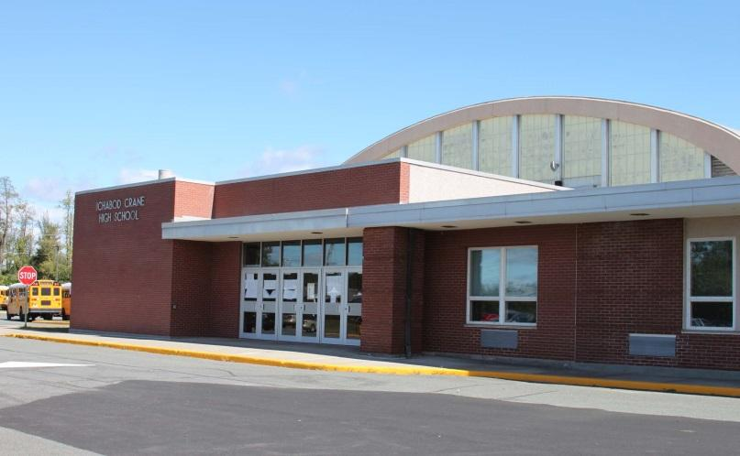
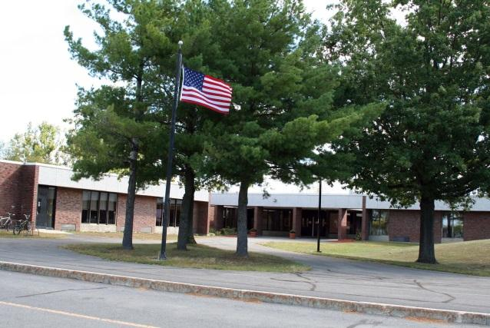
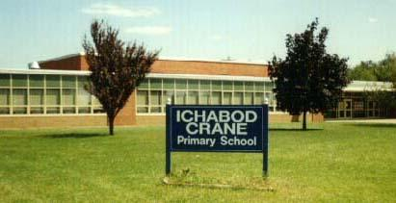
ICCSD Substitute Qualifications and Procedures

What do I need to do to become a substitute teacher or teacher assistant?
- You need to have a high school diploma to be eligible to sub at ICCSD.
- You must fill out our substitute teacher/TA application located on our website. On this application you MUST include at least 3 references. http://www.ichabodcrane.org/employment/SubstituteTeacherApplication.pdf
- You must be fingerprinted by the New York State Education Department (The paperwork and payment is taken at IC Central Office. The cost is $99.70).
- After you hand in your paperwork to IC Central Office you will be called for an interview with a district administrator.

Accepting a sub position at ICCSD

You have now been interviewed and accepted a position as a substitute at IC……
- You will receive a welcome letter from the superintendent’s office stating that you have been approved by the Board of Education and that you must come to our central office to complete payroll information.
- You will then receive a letter about our sub system, Frontline Absence Management. This letter will have the Frontline website, your user name and PIN (personal identification number). Your settings will already be done for you so you can just log on.
- You may want to click on the “help” tab to get you started. In this tab there are some videos and frequently asked questions.
- Once you are signed up you will start receiving phone calls about open positions. You can also go on the website to seek out job openings.
Job Expectations

What is expected of me as a substitute teacher or TA?

- Be neat in appearance and dress. Dress professionally, comfortably, and in good taste.
- Arrive on time and ready to teach.
- Do not talk on your cell phone during instructional time. You are free to do so during lunch or breaks.
- Please remember you are being paid to teach or supervise the students. Do not take your book, newspaper, iPad, etc. to the classroom while instructing. You are expected to follow any sub plans left by the teacher.
- Please remember that you are a role model for the students. Anything you say or do while on school grounds reflects upon you personally and professionally. Please consider this while having conversations with or around students and other faculty.
- Please refer to building guidelines for specific expectations and guidelines.

\
Ichabod Crane Primary 518-758-7575, Ext. 6001
Mrs. Andrea Williams, Principal

Parking: You may park in the parking lot in front of the building or the side parking lot. It is important that you arrive at a time that will give you sufficient time to sign in, reach your classroom and be ready to begin your day by 7:40am.

Morning Procedures

- The substitute teacher’s day runs from 7:40am – 2:40pm.

- Half day hours are from 7:40am to 11:10am or 11:10am to 2:40pm

- Report to the Main Office and sign in. Please take the teacher’s sub folder from the top drawer of the file cabinet and sign in on the sign-in sheet and take a temporary ID badge from the white basket located on the top shelf next to the file cabinet in which you took the sub folder. (Please return both folder and badge at the end of the day) Please see Ms. Hodges if you have any questions.

- Check the teacher’s schedule to see if you have a morning duty before homeroom. It is expected that you be in the classroom and ready to begin the day at 7:40am.

- Check teacher’s mailbox (in the faculty room) for attendance/lunch envelopes or anything that may need to be sent home with students.

- Before students arrive please locate the red emergency folder and familiarize yourself with the drill procedures, including locating the nearest exit from your classroom.

  - 7:40am - Students begin to arrive and go to their classrooms and/or breakfast.

  - 8:10am - Bell rings for students to be in their classroom and ready to hear morning announcements.

  - 8:10 – 8:15am - Pledge of Allegiance and morning announcements are broadcast over the PA system. For Classroom Teachers Only: Take attendance and lunch counts. Both need to be completed digitally by 8:45am.

  - 8:10am- Academic day begins

Afternoon Procedures

- 2:15pm - Afternoon announcements begin. “ Regular every day pick- ups” will be announced at this time – these students (there is a list provided) may now come to the lobby. Other students being picked up will also be called at this time.

- Wait for the announcement dismissing the grade level you are teaching.

- Leave any notes for the teacher on their desk. Return temporary staff ID badge and teacher sub folder to the Main Office.

- Substitute teachers are to remain on duty until 2:40pm.

Helpful Info:

- Bathrooms are located down the hall from the office before you enter the faculty room. Also there is one next to the Library in Kindness Way.

- The faculty room is located down the hall from the Main Office. A refrigerator/microwave is located in the room for your convenience.

- Lunches are available in the cafeteria for $5.50. Please call Ext. 6024 to reserve your lunch if you so wish.

Welcome to the Primary School, and thank you for being such an integral part of our students’ education. If you have any questions please feel free to contact Mrs. Williams, Principal.

Important Phone Numbers for the Primary School
Main Office | Kelly Hodges | 6002
Main Office | Dawn Richardson | 6001
Nurse | Faith Kubow | 6304
Kitchen Office | Jen Minahan | 6301
Custodial Office | Camille Praga | 6023

Ichabod Crane Middle/Elementary School 518-758-7575 ext 5001
Mr. Timothy Farley, Co-Principal
Mr. Anthony Marturano, Co-Principal

Parking: please park in the parking lot to the right of the building. Please do not park in front of the school. This area is reserved for buses. Please arrive no later than 7:35am.

Morning Procedures

- The substitute teacher’s day runs from 7:35am – 2:35pm.

- Half day hours are from 7:35am to 11:05am or 11:05am to 2:35pm.

- Report to the Main Office and sign in.

- Pick up your substitute folder for the teacher you are in for along with a temporary staff ID badge (RETURN THIS AT THE END OF THE DAY PLEASE).

- Check the teacher’s schedule to see if you have a morning duty before homeroom. It is expected that you be in the classroom and ready to teach at 7:35am.

- Before students arrive please locate the red emergency folder near the door and familiarize yourself with the drill procedures, including locating the nearest exit from your classroom.

- Located in your sub folder (for teachers only) is a lime green “emergency card.” Should you require immediate assistance from an administrator, give this card to a student and have them run it down to the office.

- The teacher schedule may not include additional assignments for planning/”free” periods, so please check with one of the secretaries to see if you have been assigned elsewhere during these times.

  - 7:35am - Students arrive and go to their lockers (Middle School students only) and/or breakfast.

  - 7:48am - Bell rings for students to report to homeroom.

  - 7:48-7:54am - Homeroom- Announcements and the Pledge of Allegiance will be broadcast over the PA system. For Homeroom Teachers Only: Take attendance and call Ext. 5001, Lisa Schmitt, with absences. On Mondays, Tuesdays and Thursdays, please have students sign up for the late bus in the library.

  - 7:56am - Students go to Period 1. Please follow the schedule you were provided.

Afternoon Procedures

- 2:23pm - Afternoon announcements begin. Students who are called to a particular area should be allowed to leave the classroom.

- Wait for the announcement dismissing the grade level you are teaching.

- Return any paperwork to the Main Office and place any student work and the Substitute Record Sheet in the absent teacher’s mailbox. Return temporary staff ID badge and teacher sub folder to the Main Office.

- Substitute teachers are to remain on duty or available for duty the full school day, until 2:35pm.

Helpful Info:

- Bathrooms are located in the Main Office.

- The staff room is located in room 421. A refrigerator/microwave is located in the room.

Welcome to our school and thank you for being such an integral part of our student’s education. If you have any questions please feel free to contact either Co-Principal Tim Farley or Co-Principal Anthony Marturano.

Important Phone Numbers for ES and MS
Main Office | Kathy Gulisane | 5002
Main Office | Jacqui Cole | 5007
Greeter/Attendance | Lisa Schmitt | 5001
Nurse | Sara Altomer | 5041
Kitchen Office | Carly Wills | 5060

Ichabod Crane High School 518-758-7575 ext 4001
Mr. Craig Shull, Principal
Mrs. Marcella Sanchez, Assistant Principal

Welcome to our school and thank you for being such an integral part of our student’s education. If you have any questions please feel free to contact either Principal Craig Shull or Assistant Principal Marcella Sanchez.

Parking: Please park in front of the auditorium entrance in spots 73 - 79. Please arrive no later than 7:25am.

General Expectations:
- Show up on time and review any materials left by the teacher/TA/secretary.
- Be professional - Remember that you are a district employee. Be careful how you interact with the children even if you know them.
- Dress appropriately.
- You are not to take pictures of the students and cannot post them to any social media accounts.
- Please be careful of conversations you have in front of students. You should not be discussing personal information, grades, addresses, phone numbers, or anything of a confidential manner in front of them.
- Cell phones and electronic devices should be put away while students are in the classroom.
Morning Procedures

- The substitute teacher’s day runs from 7:25am – 2:25pm.
- Half day hours are generally from 7:25am to 10:55am or 10:55am to 2:25pm. If you are subbing on a building or district wide half day, you are expected to remain until 11:30am.
- Report to the Main Office and sign in.
- Pick up the substitute folder (specifically for the teacher for whom you are covering) along with a temporary staff ID badge (RETURN THESE AT THE END OF THE DAY PLEASE).
- Check the teacher’s schedule to see what morning duty you are assigned to. It is expected that you are in the classroom and ready to teach or at your assigned duty at 7:25am.
- Before students arrive please locate the emergency folder and familiarize yourself with the drill procedures, including locating the nearest exit from your classroom. Should you require immediate assistance from an administrator, dial 4002 or 4003 from your classroom phone.
- The teacher schedule may not include additional assignments for planning/”prep” periods, so please check with one of the secretaries to see if you have been assigned elsewhere during these times.
  - 7:30am - Students arrive and go to their lockers and/or breakfast.

  - 7:40am - Warning bell rings for students to report to Homeroom. A second warning bell will ring at 7:43am.
  - 7:45-7:50am - Homeroom- Announcements and the Pledge of Allegiance will be broadcast over the PA system. For Homeroom Teachers Only: Take attendance and call the Greeter/Attendance Clerk (x4001) and report all absent students to her. On Mondays, Tuesdays, and Thursdays, please have students sign up for the late bus using the Google Form that is emailed to them.
  - 7:50am - Students go to Period 1/Block 1. Please follow the schedule you were provided.
  - As a substitute teacher, it is expected that you will completely follow all the teacher’s plans for the day, help students complete all the work assigned by the teacher, and maintain an orderly and collegial atmosphere in the classroom.

Afternoon Procedures

- Approximately 2:15pm - Afternoon announcements begin, if there are any. Students who are called to a particular area should be allowed to leave the classroom.
- Wait for the announcement to dismiss. Please listen for the announcements and do not dismiss your students until the announcement is made.
- Return any paperwork to the Main Office and place any student work in the absent teacher’s mailbox. Return temporary staff ID badge and teacher sub folder to the Main Office.
- Substitute teachers are to remain on duty or available for duty the full school day, until 2:25pm.

Helpful Info:
- Bathrooms are located in the Main Lobby.
- A refrigerator and microwave are located in the Faculty Room (Room 205).
- Log onto the computer: You will be given your own login information when hired.

Important Phone Numbers for the High School
Main Office | Holly Kilcer | 4002
Main Office | Kelly Hill | 4003
Greeter | Carol VanDenburgh | 4001
Nurse | Michelle Warner | 4093
Kitchen Office | Lisa Wills | 4089

Emergency Procedures

What do I do in a drill or real emergency?
- Located in each classroom in the district should be a red emergency folder. In this folder there are specific directions for what to do during a drill or emergency. Please familiarize yourself with these at the start of each day.
- Please review the map in your classroom which displays the quickest exit from your classroom
- In the instance where somebody is injured, please call the main office immediately (see contact numbers for each building).

Pay Scale
How much will I get paid if I sub at ICCSD?
 | Pay Scale
Uncertified Teacher | $105/day
Certified Teacher | $120/day
Uncertified Teaching Assistant | $95/day
Certified Teaching Assistant | $100/day
Term Substitute Teacher | $190/day
NYS Certified Retired ICC Teacher | $140/day
NYS Certified Retired ICC TA | $105/day

Technology in the Classroom

If a teacher leaves plans which include the use of technology or the overhead projector, you will need to do the following:
Log in to the computer:
- Power on the computer and monitor.
- Login to the teacher computer using your Ichabod Crane ID and Password.
- If you have not logged on to this computer before, it may take a few minutes to load your profile.
- Open Google Chrome and login to your Ichabod Crane Google account.

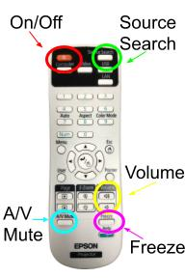
Using the Overhead Projector and Remote
On/Off: Press the on/off button once to turn the projector on and twice to turn the projector off.
Source Search: If there is a blue screen displayed on the white board, click source search. This will instruct the computer to look for any source which should be projecting on the screen. You may need to press this button multiple times as the computer scans each input source.
A/V Mute: Pressing this button will temporarily stop projection and mute sound.
Volume: If you are playing a video and have difficulty hearing the sound, try adjusting the volume on the remote.
Freeze: This function will keep the projected image “frozen” on the screen and will not change until the freeze button is pressed again.

Technology Troubleshooting
Video
- Make sure the projector is turned on (a green light will appear on the underside of the projector to indicate that it is on).
- Make sure you have logged onto the computer.
- Press the Source Search button on the remote to toggle through the input options available on this computer (usually “Computer 1”).
- If there is a document camera connected to the computer, press the power button. Then use Source Search on the remote to toggle through the input options again.

Audio
- Press the Mute button on the remote to ensure mute is turned off.
- Turn the volume up on the remote.
- Check for external speakers attached to the computer. Turn power on and volume up.
- Verify that headphones are not plugged into the computer.

TIPS, TRICKS, AND IDEAS TO HELP YOU

Remember! Always follow any instructions from the classroom teacher as closely as possible. For the times when a student (or the class!) needs something extra to do, you can prepare yourself by having your own substitute survival kit ready to go when you are!

- Check out these great websites for ideas and resources to help you put together your own ‘Bag of Tricks’!

Enchanted Learning

https://sites.google.com/site/stephaniefilardo/substitutes

http://www.substituteteachingatoz.com/resources.html

- 6 Quick Lesson Ideas for Substitute Teachers
Here are 6 quick lesson ideas that you might use for your next substitute teacher engagement. Just keep them in a tote bag and use them where necessary.

1. Create puzzles.
Word search, crossword, and other printable word games are great when you need something to use in the classroom. Simply print off a bunch of different puzzles and carry them with you when you are substituting.

2. Brick Brainstorm.
Come up with a lesson subject, such as electricity, technology, etc. Prepare bricks by using red construction paper. Give each student a brick. Now pose a question to the class, such as “What would you have done differently, if you invented the light bulb?” Let students write their responses on their brick. Then have students come up with their brick and explain their answer. Tape the brick to a wall, and as each child comes up, keep adding to make an entire brick wall.

3. Story Starters.
Tell the students what the lesson is about, and then write a story starter on the whiteboard such as for a rainforest theme, “One day I was walking through the forest in Savanna, when I heard…” Now let another volunteer come up and add a sentence to the story. If you do not have time to finish the story before class ends, make it a homework assignment for the students to finish the story and bring it back the next day to give to their teacher.
4. Getting to Know You.
Have students write an essay about themselves. Ask them to write the answers to these questions (and come up with others): “If you won a million dollars, what would you do with it? If you could be anything in the world, what would you choose? What is the best vacation you ever had?”

5. Lead a group discussion.
If your class seems to be under control, leading a discussion is a great way to talk about a lesson. Examples of discussion questions might include: “If there weren’t such things as rules, what would the world be like? What do you think is the worst thing about school? How about the best? ” Who are some of your heroes? What makes them so great?”

6. Riddles.
Use riddles that stretch the brain to think hard. Of course, make them grade-appropriate, but somewhat challenging. For instance ask them: “What gets wet the more you dry with it? The owner of a hotel wants the room doors numbered in order. There are 100 rooms. You must go out and buy the numbers to hang on all the doors. How many of each digit, 0 thru 9, will you need to buy?”

- Reading material to check out:

The Substitute Teacher's Organizer: A Comprehensive Resource to Make Every Teaching Assignment a Success by Jan Herbst

Substitute Teaching from A to Z by Barbara Pressman

The Ichabod Crane Central School District hereby advises students, parents, employees, and the general public that it offers educational opportunities including vocational opportunities without regard to sex, race, color, national origin, handicap or religion. Inquiries regarding this non-discrimination policy may be directed to: Title IX Compliance Officer, Lucas Christensen, Assistant Superintendent, Ichabod Crane Central School, Valatie, NY 12184 (518) 758-7575 and Section 504 Compliance Officer, Peg Warner, Director of Special Education, Ichabod Crane Central School District, Valatie, NY 12184 (518) 758-7575. A copy of the “In
Compliance with Section 1.4 (a)” is available in the Superintendent’s Office.

